What do you do if your assumptions for Cox regression fail?

The Cox regression model has a fairly minimal set of assumptions, but how do you check those assumptions and what do you do if those assumptions are not satisfied?

Non-proportional hazards

The assumption that is so important that it appears in the name of the Cox proportional hazards model is the asumption of proportional hazards. You can sometimes spot a violation of this assumption by comparing Kaplan-Meier curves. If the curves cross, as shown below, then you know you have problems.

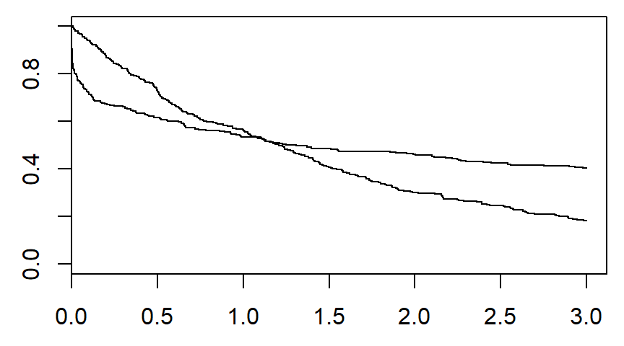

If one curve tends to level off while the other continues to drop to zero, you have a problem.

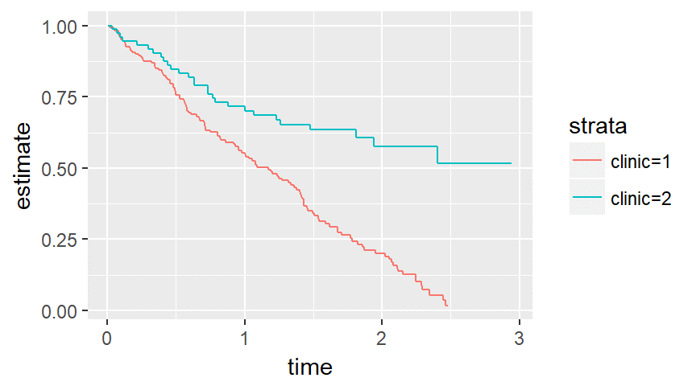

You can also diagnose non-proportional hazards using a complementary log-log plot and the Schoenfeld residuals.

You can address this problem using stratification or time-varying covariates.

Nonlinear covariate relationships

The Cox model assumes that each variable makes a linear contribution to the model, but sometimes the relationship may be more complex. You can diagnose this problem by plotting the covariate versus the Martingale residuals, though these plots are tricky to interpret.

If you have a nonlinear relationship, you have several options, but a spline function offers a simple and flexible solution. Compare the fit provided by the spline versus the fit provided by the linear function using graphs or a goodness of fit measure like AIC.

Lack of independence

Lack of independence is often something you notice during the design of your study because certain features of the design, such as centers in a multi-center study are likely to produce correlated outcomes.

You can adjust the standard errors to account for this correlation using a cluster effect or you can model the effect using a frailty term. The frailty term is a random effect, often a gamma distributed effect, that is added to the model. The extra source of variation will allow for variations at different levels of the hierarchy.